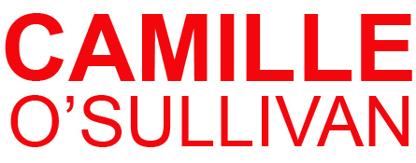

 **Time Out**

# cutout fig

**CHANGELING**

**TOUR**

***She treats every song as an intense emotional journey…hypnotic… such an outpouring of passion you can't resist being drawn into her web*  **Independent

Previously an **award winning architect and painter,** Irish-French Camille O'Sullivan is a singer/actress who enjoys a formidable international reputation for her unique dramatic interpretations of the narrative songs of **Nick Cave, Brel, Waits, Bowie, Radiohead,** **Arcade Fire**.  The award-winning singer – an original star of the **Olivier Award-winning *La Clique*** - has stunned audiences around the world with 5-star sell-out performances, her solo shows include **Sydney Opera House, London’s Royal Festival Hall, The Roundhouse** 6 week **Apollo Theatre London West End** run and a show-stealing appearance on ***Later with Jools Holland* BBC and Ina’s Nacht**

**ALBUM:** Camille released her album ***Changelin****g* in the **UK to rave reviews (“*A one-off:******there is no-one like Camille in popular music today*” Neil McCormick, Telegraph; “*powerful*” Independent (UK) ****;** “*impressive*” Hot Press ****,). *Changeling* is an album of interpretations by the likes of Radiohead, Nick Cave and Arcade Fire, as well as 3 original songs, one penned especially for Camille by **Snow Patrol’s Gary Lightbody, who says “*Camille is one of the most original female voices of the last ten years”*.**

***Ravishing, a superb performer and great singer… the star is her singing voice, a deep sultry instrument that might have been created to express desolate love*** The Guardian

**SHOW: Chameleon-like on stage,** each song has a different character with its story to tell. Dark, fierce, amusing and mesmerizing, **As much a storyteller as a singer**, or actress interpreting a monologue, **Camille transforms each song** into an intense theatrical experience, the show has been described as **an emotional rollercoaster** drawing her audience into a world illuminated by the dark and the light.

***A cross between Sally Bowles, Patti Smith and P J Harvey… a major star* ** Scotsman

**THEATRE:** Recently **Camille starred in Edinburgh International Festival** an won a prestigious **Herald Angel Award for** her tour de force, solo performance in the **Royal Shakepeare Company’s** *Rape of Lucrece*’. The epic poem was adapted for stage with **original music by Camille** and her MD Feargal Murray created original music and song for. It brought glowing reviews from critics and public at **Edinburgh, Sydney Festivals,Melbourne ,Holland, Dublin Theatre Festival include5 star reviews** “***a triumph*” Times; "*magnificent"* Guardian; “*emotive… gorgeous”* Herald; “*accomplished*” Telegraph; “*exquisite*” Evening News; “*tremendous range and intelligence*” Scotsman**

## *When she sings it's as though her breath is soaked in paraffin - one spark, and the whole room would ignite*  Daily Telegraph

She recently perfomrmed with **The Pogues** **in London’s O2 Arena**, duetted with **Tim Robbins, Todd Rundgren, Martha Wainright**, and was in **Stpehen Frears film Mrs Henderson Presents** alongside **Dame Judi Dench and Will Young**. Recently Camille was chosen by **Yoko Ono** to perform Double Fantasy Live at Meltdown Royal Festival Hall alongside **Patti Smith and Sean Lennon.** She received great reviews  ***“O'Sullivan's lyrical performance the real show-stopper” Mojo Mag***

**AWARDS**: She has won several “**Best Music” Awards (Dublin, Brighton, Melbourne Festivals and a Spirit of the Fringe Award at Edinburgh Fringe**, where she is regularly one of the top-selling performers. **Irish Tatler Woman of the Year Music Award (2011) and Herald Angel Award (2012).**

***A courageous and singular performer, Camille is one of the most gifted interpreters of narrative songs yet to appear****…*   Irish Times

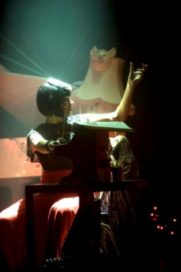

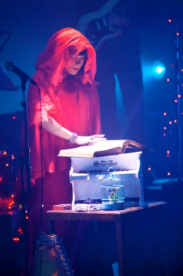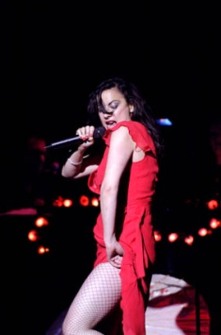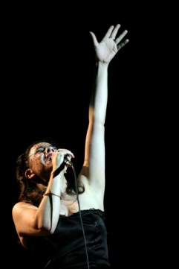



***Camille is a marvellous ambassador for***

***Irish artistic excellence on a global stage***

Eugene Downes (CEO, Culture Ireland)

***Camille is one of the most original female voices of the last ten years. Her voice is astonishing; she’s one of the great live performers ever to come from Ireland***

**Gary Lightbody** (Snow Patrol)

**Film/TV**

***Mrs Henderson Presents***(Dir: Stephen Frears); with Dame Judi Dench, Bob Hoskins, Will Young

***Summer in February*** (2013), ***Over the Edge***, ***November Afternoon*** (Dir John Carney of ‘Once’ ).

***Later… With Jools Holland*** (BBC2 TV), ***The Late Late Show*** (RTE TV) 9 appearances

Interviewed by **Sir David Frost** - Frost Over the World (Aljazeera English)

**Theatre** **La Clique/La Soiree** (Olivier Award winning original cast member

**Dublin Theatre Festival** – ***The Lulu House*** (with Lorcan Cranitch)

**Royal Shakespeare Company**– ***The Rape of Lucrece*** (adapted and music co-written by Camille)

***Sweeney Todd (***Gate Theatre, Dublin), ***Tonight Lola Blau***(Co-Opera Theatre, **Jacques Brel is alive and well** (Andrews Lane Theatre. **Spiderman** **Broadway** Workshops **Julie Taymour** and **U2**

**Awards**

**Herald Angel (Performance)** Edinburgh International Festival 2012

**Woman of the Year (Music)** Irish Tatler (2011)

**Best Spiegeltent Show** Dublin Fringe 2008 /2010

**Spirit of the Fringe** Edinburgh Fringe

**Best Music** Brighton Festival Awards

**BestPerformer** Brighton Festival Awards

**Best Music Artiste** Melbourne Green Room Theatre Awards

**Olivier Award** (as cast member) La Clique Best entertainment

**Nominations**

**Best Female Artist Award**  Irish Music Meteor Awards 2009

**2011/12 Highlights**

**Under the Radar, New York** (supported by Culture Ireland)

Release of **new studio album – *Changeling***

**Royal Shakespeare Company** ***Rape of Lucrece***at Edinburgh International Festival; also performed ***Changeling*** at the Edinburgh Fringe – the first time any performer has headlined shows at both in the same year.

**Special guest appearances** include performances with

* Rogues Gallery: **Hal Willner, Tim Robbins, Todd Rundgren, Marianne Faithfull** at Sydney Festival
* Les Nuits De Fourvière – *Tom Waits’ Raindogs Revisited* ,**Tigerlillies St Vincent, Jane Birkin**
* Supporting Jools Holland’s Big Band at **Royal Albert Hall and SECC Glasgow**)
* Sharon Shannon’s Big Band (with Shane MacGowan)
* Duetting with **Shane McGowan** 25th Anniv Fairy Tale of NY at **London 02**
* Martha Wainwright and Beth Orton in the *Way to Blue Nick Drake tribute*

**Marc Almond, Diamanda Galas and Arno** in *Brel Tribute Show*, Barbican, London

**Yoko Ono Double Fantasy Live 2013 with Patti Smith, Earl Slick and Sean Lennon**

***bittersweet, slightly twisted, darkly sexy and emotionally revealing…***  **Australian Stage**

**Recent Solo headline Performances** include

**London: Royal Festival Hall** 6 week run **- Apollo Theatre, Roundhouse, Queen Elizabeth Hall** ,**: Sydney Opera House, Hamer Hall Melbourne, London Feis 2011** (headline (2nd Stage); main stage inc Bob Dylan, Van Morrison), **Edinburgh Fringe** (4 week runs) 2004-2013, **Latitude** and **Glastonbury. Yoko Ono Meltdown, Montreux Jazz festival, The Barbican**

***We gave Camille five stars last year, after this performance we'd give her six if we could* Metro**

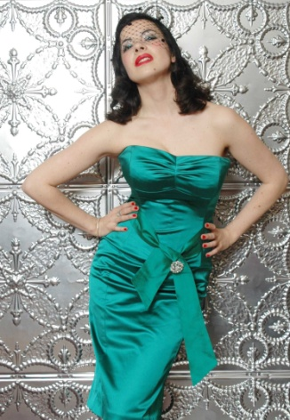

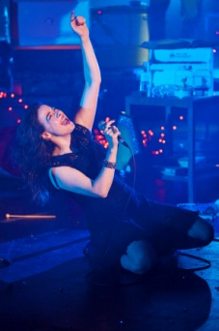

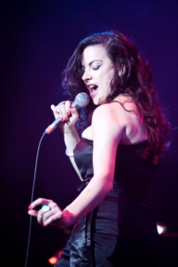

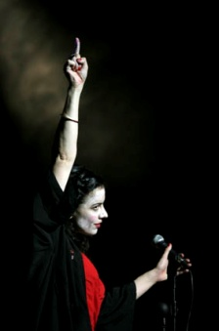

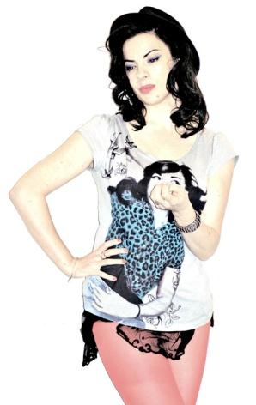

Camille O’Sullivan **Online**

Websitewww.camilleosullivan.com

YouTubewww.youtube.com/camilleosullivan

Myspacewww.myspace.com/camilleosullivan

Twitter www.twitter.com/camilleos

Facebook (fan page) www.facebook.com/#!/pages/Camille-OSullivan/14453614182

For more information please contact

**info@camilleosullivan.com** (email)